**CIS-350  
Infrastructure Technologies**

**Lab 2 Report**

**Student Name**: **Jessica Hoffman**

1. Insert *Lab2_Tree* file from p. 8 of the Lab 2 instructions into the space provided or use the *Alt-PrtScr* keys to capture the screen output (window) from command *TYPE Lab2_Tree* on p. 8 and paste that window here.

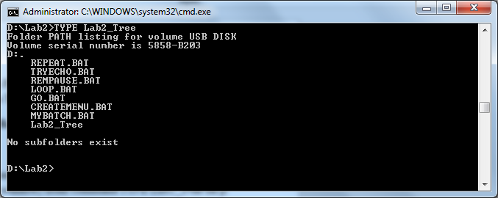

2.

1. ECHO OFF
2. ECHO LOOP.BAT
3. C: TREE
4. C: TREE /F
5. MD \CLASSES
6. ERASE \BOOK
7. COPY Go.bat \CLASSES\Go.bat
8. PAUSE
9. DIR | MORE
10. SORT < Letter3 > Letter3_Sorted
11. Describe step by step what a file named MYBATCH does.

**ECHO OFF**

**REM STARTING BATCH FILE**

**TREE /F**

**PAUSE**

**DIR**

**PAUSE**

**MD JOE MARY STACY**

**TREE /F**

**PAUSE**

**COPY *.BAT E:\LAB2\STACY**

**TREE /F**

**PAUSE**

**CD STACY**

**ERASE *.BAT**

**PAUSE**

**CD ..**

**TREE /F**

**PAUSE**

**RD JOE MARY STACY**

**TREE /F**

**PAUSE**

**REM CLOSING BATCH FILE**

The ECHO OFF command hides subsequent commands from appearing in the console. REM displays STARTING BATCH FILE on the screen. TREE /F displays the contents of the current directory including files and subdirectories as a tree. PAUSE stops program execution until a key is pressed, then it resumes. DIR displays the entire contents of the current directory, including date modified, type, file size, and file name. PAUSE stops program execution until a key is pressed, then it resumes. COPY *.BAT copies every file in the current directory ending with the .BAT extension and pastes them into the directory location E:\LAB2\STACY. TREE /F displays the contents of the current directory including files and subdirectories as a tree. PAUSE stops program execution until a key is pressed, then it resumes. CD STACY switches the current directory to be STACY. ERASE *.BAT erases all files in the current directory ending with the .BAT extension. PAUSE stops program execution until a key is pressed, then it resumes. CD.. changes directories to the immediate parent directory of the current one. TREE /F displays the contents of the current directory including files and subdirectories as a tree. PAUSE stops program execution until a key is pressed, then it resumes. RD JOE MARY STACY removes the listed 3 directories. TREE /F displays the contents of the current directory including files and subdirectories as a tree. PAUSE stops program execution until a key is pressed, then it resumes. REM displays CLOSING BATCH FILE on the screen.